Data Science - Bank Marketing Campaign

# Group Information

Group Name: Datalux

Group Members: 3

|  |  |  |  |
| --- | --- | --- | --- |
| Name | Email | Country | Uni/Company |
| Huu Thien Nguyen | [nguyenhuuthien27296@gmail.com](mailto:nguyenhuuthien27296@gmail.com) | Sweden | Skövde University |
| Asmaa Alqurashi | asmaa.idk@gmail.com | Saudi Arabia | Taif University |
| Deepak Rawat | deepakrawat68@gmail.com | Ireland | Dublin Business School |

Specialisation: Data Science

Submitted to: Data Glacier canvas platform

Internship Batch: LISUM09

# Data cleansing and transformation have been done on the data

## 2.1. Thien:

## 2.1.1. Age - Remove outliers based on quantile:

An outlier is an observation “that appears to deviate markedly from other members of the sample in which it occurs”. Note: we focus on univariate outliers, those found when looking at a distribution of values in a single dimension (Age feature).

The outliers detection procedure was based on the graphical pandas profiling library. For each feature, we drew histograms and one-way plots of the logarithms of the unit values, using each to detect the presence of gross outliers for further investigations.

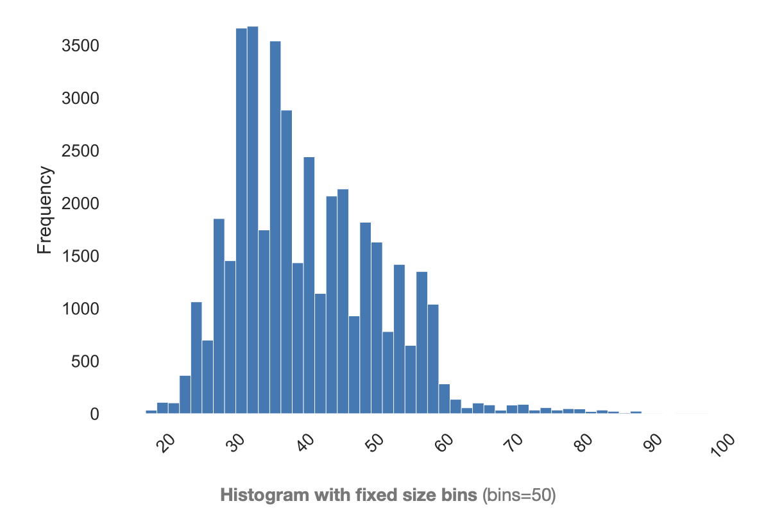

Figure 1: Age histogram visualisation

We must specify a threshold for deciding whether each observation is ‘too extreme’ (outlier or not?). Common ‘thumb-rule’ thresholds: an observation is considered an outlier if it is more than 2.5, 3, or 3.5 standard deviations far from the mean of the distribution. In our scenario, the 1% and 99% were applied to maintain the integrity of the dataset (not so many rows were affected)

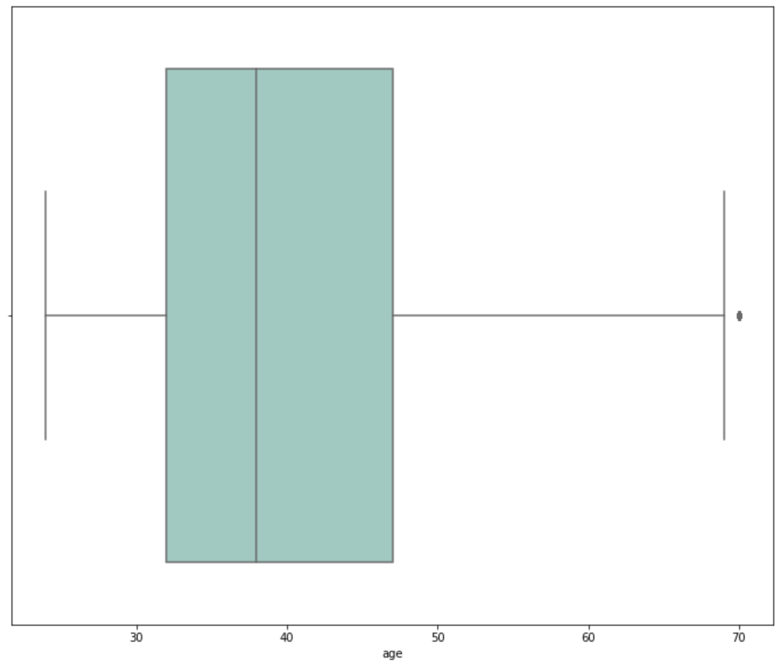

Figure 2: Age boxplot after the removal of the outliers

The age range after removal was between 24 and 70. The dataset has 40161 rows remaining, which is an acceptable amount.

## 2.1.2. Age - Binning value:

Since age is a numerical feature, the binning technique was implemented to create a new categorical, which can provide a huge insight for the model in the future. The binning range was selected as 24-30, 31-40, 41-50, 51-60, and 61-70. In the modelling step, the feature importance will be measured and the binning range will get adjusted based on the results.



Figure 3: age_binned feature

## 2.2. Asmaa:

## 2.2.1 Encode Categorical Data

Pre-process categorical data from words to the numeric value to use it in the model. To do this we will use OneHotEncoder() provided by sklearn.

## 2.2.2 Encode Target Column

Encode the target column yes = 1 and no = 0

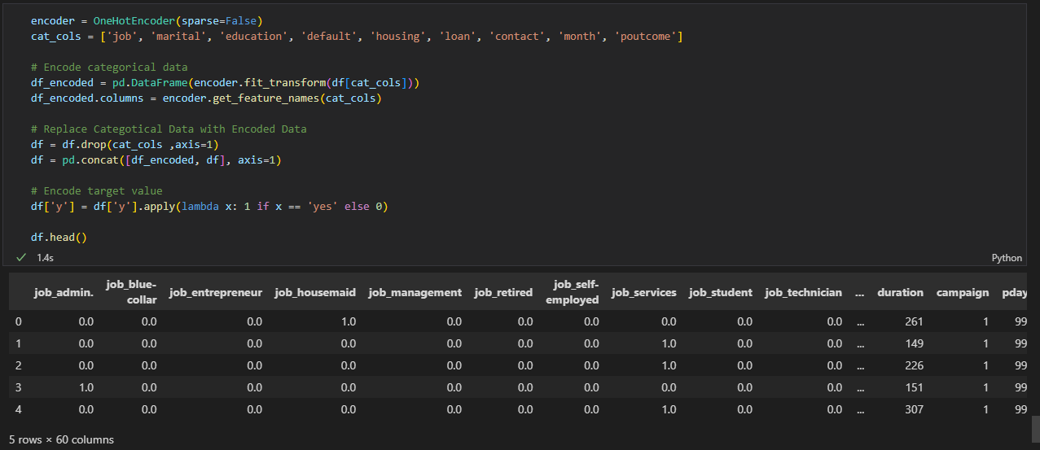

Figure 4: Encode categorical data

## 2.3. Deepak

## 2.3.1 Data Transformation

**Feature Scaling**

It is a Data Pre Processing step that is used with independent data characteristics or variables. In general, it assists in normalising the data within a specific range. It occasionally benefits in accelerating algorithmic calculations.

Feature scaling can be mainly done in three ways -

**Min-Max scaling/Normalisation** - In min-max we subtract the minimum value in the dataset with all the values and then divide this by the range of the dataset(maximum-minimum). In this case, your dataset will lie between 0 and 1 in all cases

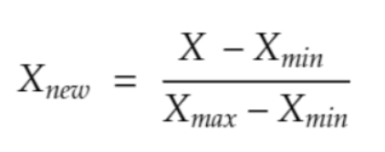

**Standardisation** - Standardisation involves rescaling the features such that they have the properties of a standard normal distribution with a mean of zero and a standard deviation of one.

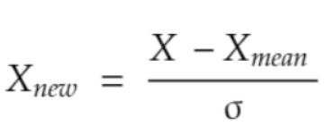

Feature scaling can be applied to the columns which contain numeric values. These columns are - 'duration', 'campaign', 'pdays', 'previous', 'emp.var.rate', 'cons.price.idx', 'cons.conf.idx', 'euribor3m', 'nr.employed'.

Min-max Scaler

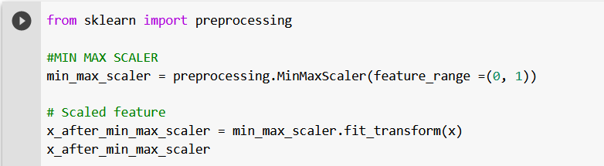

Standardisation

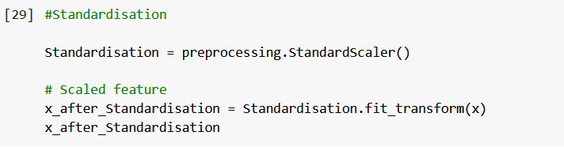

# 3. GitHub link

The link for GitHub: https://github.com/AndrewNguyen27296/DataGlacier